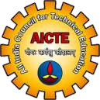 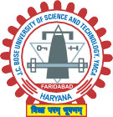

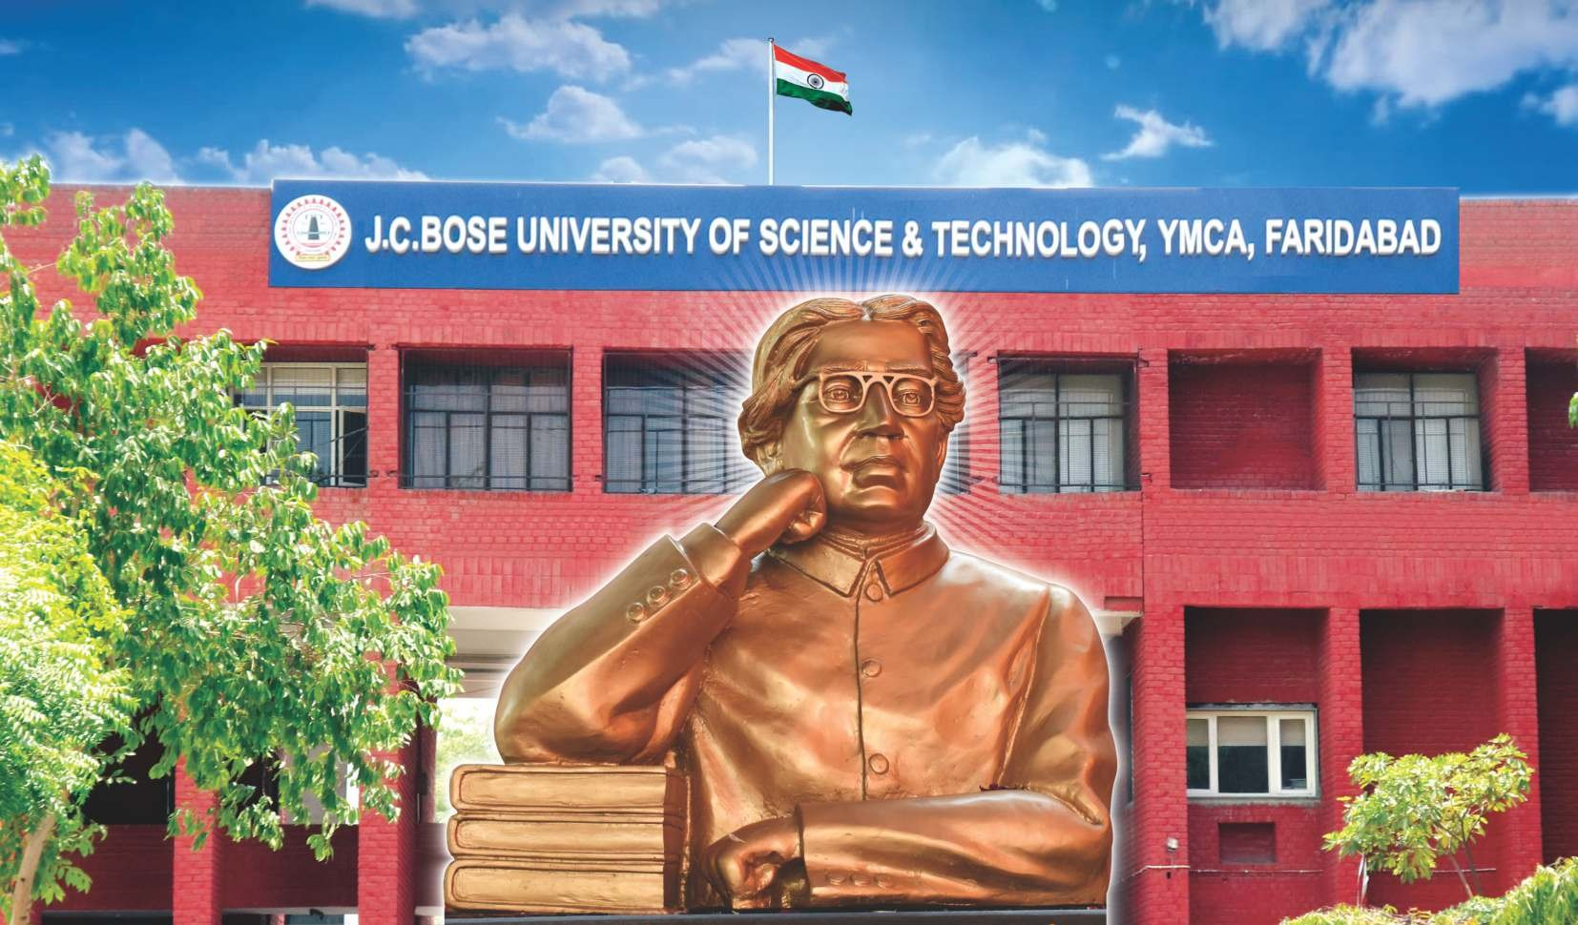

**EMAIL:** [**icrdeee2022@gmail.com**](mailto:icrdeee2022@gmail.com) **| WEBSITE:** [**www.icrdeee2022.com**](http://www.icrdeee2022.com/)

**AICTE SPONSORED**

INTERNATIONAL CONFERENCE

***on***

**RECENT DEVELOPMENTS IN ELECTRICAL AND ELECTRONICS ENGINEERING**

**(ICRDEEE 2022)**

**(15.04.2022 – 16.04.2022)**

*Organized By*

## DEPARTMENT OF ELECTRICAL ENGINEERING J.C.BOSE UNIVERSITY OF SCIENCE AND TECHNOLOGY,

**YMCA, FARIDABAD**

## About J.C. Bose University of Science and Technology, YMCA, Faridabad

**(NAAC Grade 'A')**

The J.C.Bose University of Science and Technology, YMCA Faridabad India has been accredited by National Assessment and Accreditation Council (NAAC) with 'A' Grade and a CGPA of 3.08 in the First Cycle of Accreditation.

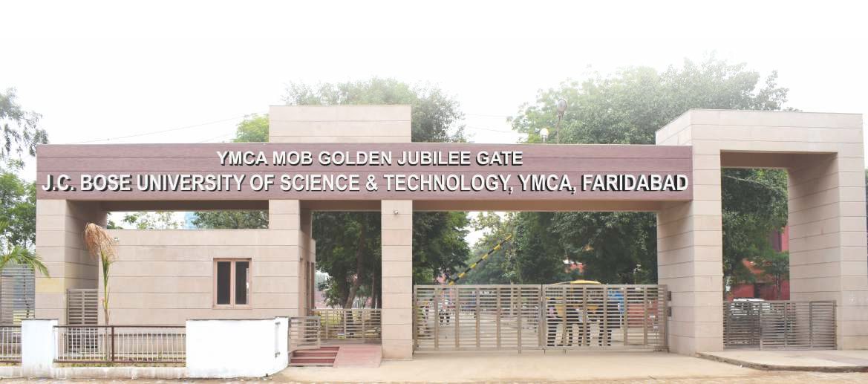JCBUST was established in 1969 as an indo-German project, a joint venture of the National Council of YMCA India, the Government of Haryana and the Central Agencies for Development Aid, Bonn, Germany. In December 2009 it was awarded the status of state university by the State Government. Right from the very beginning at institutional level, it has emphasized greatly on practical work related to industry. As a result our students are well accepted by the industries. The fact that many of them are entrepreneur with names of repute at national and international level establishes the same. The university has also added new chapters in its glorious history i.e. M.B.A., M.C.A, M.Tech. (Computer Engineering, Electrical Engineering, Electronics Engineering & Mechanical Engineering), M.Sc. (Physics, Math's, Chemistry & Environmental Sciences), M.A. (Mass Communication and Journalism) and PhD

## CONFERENCE PREAMBLE

The AICTE sponsored International Conference on Recent Developments in Electrical and Electronics Engineering (ICRDEEE 2022) aims to facilitates a intriguing platform for worldwide researchers and scientists from academia , industry delegates to discuss proposals and disseminate result on their innovative ideas, trends, and concerns .It strives to provide a transformative professional experience in order to catalyze practical challenges encountered and solutions adopted in the ﬁelds of Electrical and Electronics Engineering. The extensive goal of two -days International conference ICRDEEE 2022 is to offer a unique opportunity for community wide discussion identifying the cutting edge technology in premier interdisciplinary areas of Electrical and Electronics Engineering.

#### Chief Patron



**jcboseust.ac.in**

**/JCBoseUST**

###### Shri Bandaru Dattatreya

Hon'ble Governor, Haryana & Chancellor JCBUST, YMCA Faridabad

#### Patron

###### Prof. Dinesh Kumar

Vice Chancellor

JCBUST, YMCA Faridabad Conference Chair

#### Conference Chair

###### Prof. Poonam Singhal

Chairperson (Electrical Engg. Deptt) JCBUST, YMCA Faridabad

#### Convener

###### Dr. Sakshi Kalra (8860988607)

Electrical Engg. Department

J.C. Bose University of Science and Technology, YMCA, Faridabad.

#### Co-convener

###### Nitin Goel (9313241442)

Electrical Engg. Department

J.C. Bose University of Science and Technology, YMCA, Faridabad

## Registration Fee



**jcboseust.ac.in**

**/JCBoseUST**

Participants are requested to register in advance. The enclosed registration form or its photocopy may be ﬁlled and sent along with the full length paper. The registration fees for the participants is detailed as below.

|  |  |
| --- | --- |
| **REGISTRATION FEE** | |
| Faculty | Rs 7000/- |
| Full time Students: & Research Scholar: | Rs 5000/- |
| Industrialists | Rs. 8000/- |
| International Delegate: | 70$ |
| Accompanied person: | Rs. 2000/-. |

Registration fee can also be submitted online with A/C No. 146601000000088, MICR Code – 110020044 and IFSC Code – IOBA0001466

Participants must register by 1st March,2022 otherwise their paper shall not be considered for publication. All submitted manuscripts will undergo peer review before acceptance in the conference.

## Important Dates

|  |  |
| --- | --- |
| *Early bird Submission | 15 December 2021 |
| #Last date of submission of full length paper | 31 December 2021 |
| Notiﬁcation of acceptance of full paper | 15 January 2022 |
| Last date of submission of camera ready paper for selected Journal | 01 February 2022 |
| Last date of submission of camera ready paper for Conference proceeding | 15 February 2022 |
| Last date of Registration | 01 March 2022 |

###### *Early bird submitted manuscripts received only up to 15th Dec 2021 will be considered for publishing in selected journals.

**#Manuscripts received up to 31stFeb 2022 will be considered for publishing in conference proceeding with ISBN number.**

## PUBLICATION OPPURTUNITIES

All registered and presented papers in the conference shall be published in the Conference proceeding/UGC Care

/SCOPUS/SCIE indexed journal (modiﬁed version) after peer review. The fees to publish the paper in the selected journal has to paid by authors

Papers not registered/presented in the conference will not be considered for publication in journals as well as proceedings of the conference.

All accepted manuscript will be sorted based on journal policies, terms and conditions. The organizers reserve the right to select the journal for particular manuscript.

## SPONSORSHIP

ICRDEEE 2022 offers a diversity of sponsorship opportunities suitable for large as well as small organizations. Interested organizations are cordially invited for the sponsorship of various activities/events of the conference and accordingly space for the advertisement in the souvenir/time slot for the presentation during the conference will be provided. The Conference Sponsors will have a unique opportunity to strengthen their visibility and product awareness

## ACCOMODATION

Accommodation can be easily availed in nearby hotels/ guest houses. Speciﬁc request may be made in advance to arrange accommodation in nearby hotels on chargeable basis.

## CALL FOR PAPERS

ICRDEEE 2022 warmly invites full length original research papers describing novel ﬁndings and research works to the conference from academic professionals, industry delegates and research scholars from across the globe. The submitted manuscript must contribute original ideas and should not have been published or under review in any conferences/journals/ magazines. **We are soliciting contributions in (but not limited to) the following topics:**

## Topics for ICRDEEE 2022 include, but are not limited, to the following:

Power Generation, Transmission and Distribution Renewable Energy Sources and Technology Power Electronics and Electric Drives

Advanced Power System and Control Control Systems and Instrumentation

Electrical Machinery and Electrical Apparatus Electrical Machines Design and Control

Power System Protection, Operation and Control Computation Intelligence in Electrical Engineering High Voltage Engineering and Protection Electrical Materials and Process

Smart Grid Technologies and Application Electric and Hybrid Vehicles

System Modeling & Simulation Intelligent Control Systems Artiﬁcial Intelligence and IoT Biomedical Instruments

RF and Microwaves Engineering Optical Network and Communication

Remote Sensing and Satellite Communication Industrial Process Control and Automation Semiconductor Technology

Optimization Techniques VLSI Technology and Design Signal Processing

## International / National Advisory Committee

Dr. Marta Molinas, Department of Engg. Cybernetics, Norway



**jcboseust.ac.in**

**/JCBoseUST**

Dr. Ramesh Bansal, EED, University of Sharjah, UAE Prof. Akhtar Kalam, Victoria University, Australia

Dr. Jahangir Hossain, University of Technology Sydney, Australia

Prof. Mohan Kolhe, University of Agder, Norway Dr. Emre Çelik, Düzce University, Turkey

Dr. Haluk Gözde, National Defence University, Turkey Dr. Sukumar Mishra, EED, IIT Delhi

Dr. Bhim Singh, IIT, Delhi Dr. N. P. Padhy, EED,IITR

Dr. B. K. Panigrahi, EED, IITD

Dr.Narender Kumar,EED, DTU Delhi

Dr. Dheeraj Joshi, EED, DTU Delhi

Dr. Ashok De, ECED, DTU Delhi

Prof. K.S Sandhu, NIT Kurukshetra

Dr. S. K. Gupta, DCRUST, Murthal

Dr. Manoj Duhan, DCRUST, Murthal

## Technical Committee

Dr. Anshul Agarwal,NIT, Delhi

Dr. Nizamuddim, Noida Authority, U.P.

Dr. Puja Dash, GVPCE, Visakhapatnam, Andhra Pradesh

Dr. Nikhil Pathak, Tsinghua University, Beijing, China

Dr. M.K. DebnathSiksha 'O' Anusandhan University, Bhubaneaswar, Odisha, India

Dr. C.K. Shiva, S.R. Engineering College, Warangal Dr.DipayanGuha, MNNIT, Allahabad

Dr. Anil Kumar, Delhi Technological University, Delhi Dr. Rajiv Kumar, JUIT, Waknaghat, Solan, H.P.

Dr. Sandeep Dhundhara, Chaudhary Charan Singh Haryana Agricultural University, Hisar

Dr.Mandeep Sharma, Baba Hira Singh Bhattal Institute of Engineering and Technology, Lehragaga, Punjab

Prof. R.K. Sahu, VSSUT, Burla, Odisha Prof. H.D. Mathur, BITS Pilani

Prof. Nidul Sinha, NIT, Silchar Dr. L.C. Sakia, NIT, Silchar

Dr. R.J. Abraham, IIST, Kerala

Prof. Valentina Emilia Balas, AurelVlaicu University of Arad, Romania

Prof. Hany Hasanien, Ain Shams University Faculty of Engineering, Cairo, Egypt

Prof. A.P. Mittal, NSUT, New Delhi

Prof. R.C. Bansal, University of Sharjah, Sharjah, UAE

Prof. K.P.S. Rana, Netaji Subhas University of Technology, Delhi

Prof. Yajvender Pal Verma, Panjab University, Chandigarh

Prof. J.N. Rai, Delhi Technological University, Delhi

Prof. Mukhtiar Singh, Delhi Technological University, Delhi

Prof. Sanjeev Singh, MANIT, Bhopal

Prof. T.S. Bhatti IIT, New Delhi

Dr. Lalit Kumar, Shri Vishwakarma Skill University, Gurugram

Dr. B. Vedik, S.R. Engineering College, Warangal

Dr. Pankaj Dahiya, Delhi Technological University, Delhi

Dr.M.L.Aggarwal,(Dean FET),JCBUST,YMCA

Faridabad

Dr. P. R.Sharma, (EL), JCBUST, YMCA Faridabad Dr. Rajesh Ahuja (EL), JCBUST, YMCA Faridabad Dr.Anju Gupta (EL)JCBUST, YMCA Faridabad

Dr.Munish Vashishath,(ECE),JCBUST, YMCA Faridabad

Dr.Neelam Turk (ECE), JCBUST, YMCA Faridabad

Dr.Pradeep Dhimri ,(ECE)JCBUST, YMCA Faridabad

Dr.Komal Kumar Bhatia, (CE), JCBUST, YMCA Faridabad

## For Correspondence:



**jcboseust.ac.in**

**/JCBoseUST**

### Convener

##### Dr. Sakshi Kalra

Mobile No.: 8860988607

### Co-convener

##### Mr.Nitin Goel

##### Mobile No. :9313241442

Electrical Engg. Department

**For any queries, send an email at** [**www**](mailto:www.icnpstm2022@gmail.com)[**.icrdeee2022@gmail.com**](mailto:.icrdeee2022@gmail.com)

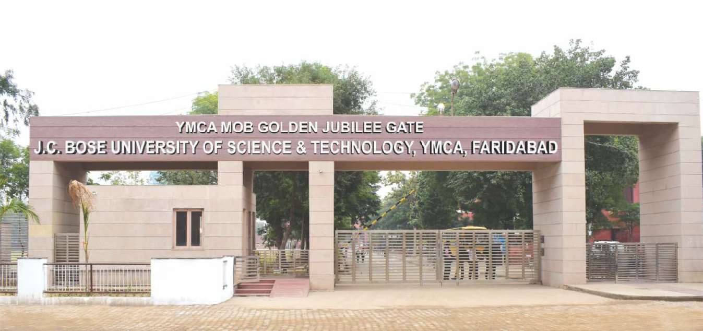

**VENUE**

J.C.Bose University of Science and Technology, YMCA Faridabad Sector 6, Mathura Road Faridabad

# FARIDABAD CONNECTIVITY

Faridabad is the most populous and largest city of the Indian state of Haryana. It is named after its founder, Shaikh Farid, the treasurer of Jahangir.

The Delhi-Mathura-Agra National Highway 2 (Grand Trunk Road) passes through the city. It is situated in the National Capital Region bordering the Indian capital New Delhi

Faridabad distinctively enjoys a strategic location with its easy connectivity to national capital New Delhi. It is well connected to Noida, Gurgaon and New Delhi via the road, train and metro.

Some major highways that pass through the heart of the city include NH 2, NH 3 and NH 4.

The DMRC (Delhi Metro Rail Corporation) incorporated the 11 distinctive metro stations across Faridabad to ensure ultimate ease in terms of traﬃc hazards as well as pollution.

The nearest airport to Faridabad is Indira Gandhi International Airport, New Delhi which is around 45 K.M. away.